**SRM UNIVERSITY ANDHRA PRADESH**



**A report on**

**“Pharmacy Web Application”**

**For the course  
“*Data Management System and Web technology*”**

**Submitted by:**

**Tata Lakshmi Durga Likhitha-AP19110010001**

**Savanth Kuricheti AP19110010063**

**Lakkireddy Harshitha-AP19110010112**

**Second Year Computer Engineering**

**Guided by:**

**PROF. SNEHAL SANJAY KULKARNI**

**Submitted To:**

**SRM UNIVERSITY – ANDHRA PRADESH**

**For ACADEMIC YEAR**

**2019-2020**

|  |  |  |
| --- | --- | --- |
| SR. NO | CHAPTER NAME | PAGE NO |
| 01. | INTRODUCTION | PAGE-**4** |
| 02. | ABSTRACT | PAGE-**5** |
| 03. | TOOLS AND ENVIRONMENT USED | PAGE-**6** |
| 04. | SYSTEM FLOW DIAGRAM | PAGE-**7** |
| 05. | ALGORITHM | PAGE-**8-9** |
| 06. | SAMPLE I/P AND O/P | PAGE-**10-17** |
| 07. | CONCLUSION | PAGE-**18** |

**CONTENT**

**ACKNOWLEDGEMENT**

Firstly, special thanks go to our project Mentor Prof. Snehal Sanjay Kulkarni, for her contribution to our project since we have started we have started up to end for support, advice and knowledge in order to achieve and complete the project successfully.

Many thanks go to our beloved professors from SRM University Andhra Pradesh at the department of Computer Science of Engineering that have taught to get the knowledge and skills in Computer science with account. Our sincere gratitude toward all staff of SRM University, we do really appreciate their support and cooperation during our entire life at University.

Finally, we would like to show our gratefulness to our group mates who have shared their thoughts during this process and for spending their time in making this project successful.

Lakshmidurga Likhitha-AP19110010001

Savanth Kuricheti-AP19110010063

Lakkireddy Harshitha-AP19110010112

**INTRODUCTION**

***Project title:*** Pharmacy Web Application

* ***Aim / Objective:*** In our project, we are going to create a web-based application that helps pharmacies, medical stores to sell medicines in a faster way. It is a user-friendly program for pharmacists that lets them handle all aspects of the pharmacy, such as medication management and billing, and improves processing efficiency. It is concerned with automating the task of bill maintenance. Billing administration is a critical method in the pharmacy. Safe medicine data storage, as well as quick browsing, deleting and upgrading the medicine. The pharmacy web application is simple to use, allowing the user to complete pharmacy tasks without challenge.
* The key objectives of this application are to make their pharmacy organizations computerized by producing organized work by reducing or eliminating waste of time as well as removing resources such as papers for data storage because most pharmacies are still paper-based and malfunctioned medical use by providing accurate information on each medication.

**Abstract:**

Nowadays, Pharmacy Management system is one of the most essential tools that are used in the medical store. It is used to manage pharmacy related activities such as medical inventory, record keeping, billing management, sales management as well as managing the stocks and information of expired medicines. In a manual procedure, it is difficult to check the expire date for every product in the medical store and also need a pharmacist assistant to check for it. By doing so it takes a lot of time to find out whether certain medicines are out of stock.

In this project we tried to develop a web based pharmacy management system. Our main aim is to allow this application to be used in most retailing pharmacies. This system is designed to overcome all challenges related to the management of medicine that were used to be handled locally and manually.

Using this system, it helps us to record all transaction made at the daily sales, to balance stock, customers.

**Tools and Environments Used**

**Languages**

* HTML – Hypertext Markup Language
* CSS – Cascading Style Sheets
* Java Script
* Mysql
* PHP – Hypertext pre-processor (earlier called, Personal Home Page)

# SYSTEM SPECIFICATION:

**Hardware Specification**:

Processor : Intel Core Duo 2.0 GHz or higher.

RAM : Minimum 512 MB or greater

Hard Disk : 20 GB (Free Space)

Monitor : Plug and Play monitor.

Mouse : Microsoft PS/2 mouse.

Keyboard : Standard 101/102 key.

# Software Specification:

Software : XAMPP.

Operation System: Windows 7 or higher.

Browser : Google Chrome, Mozilla Firefox,

Front End : Web Technology

Back end : MYSQL

Connectivity : Internet

Browser : PHP, JAVA Script, Flash Compatible Browser. (Recommended Google Chrome 33.0 and above)

Server : APACHE

**System Flow Diagram**

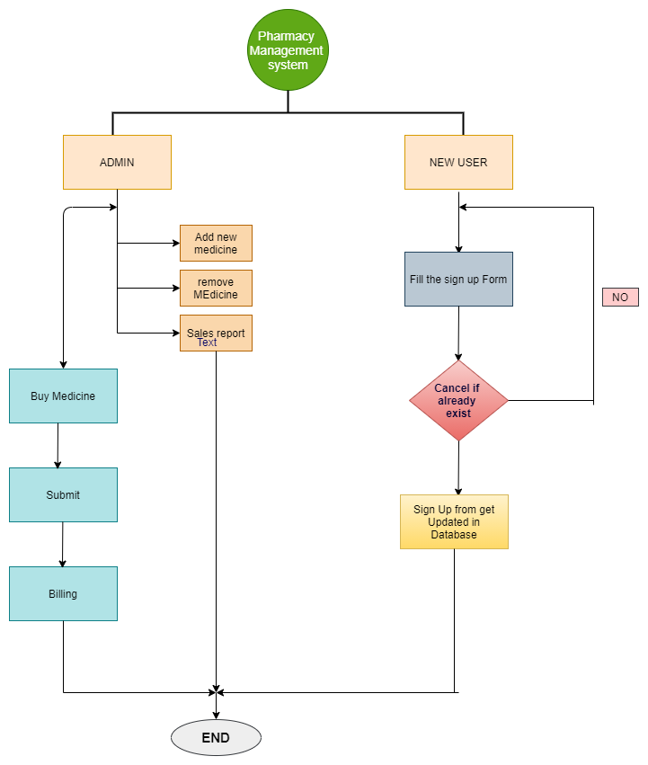

**Algorithm**

* **Step 1:**
* Begin the website
* **Step 2:**
* The first page is the login Page. User needs to enter the login information i.e Username and Password to enter into the website.
* The login page is designed using HTML and is connected to a PHP code to check the details. If the details given by the user are wrong then a warning is displayed as an invalid username and password.
* **Step 3:**
* After entering the correct details, it will take to a home page where the webpage consist a navigation bar that takes to home page, Medicine, Billing, Users and Logout button. This page is designed with HTML.
* **Step 4:**
* The user can move to the medicines page that contains all the medicines in the store. In this page the user can add new medicine, it’s type, it’s expire date, etc. After completing to add a new medicine it will be added to the medicines list.
* This page is designed with HTML.
* **Step 5:**
* In the billing page, after selecting the medicines that the user wants to buy, they should buy the medicine, and then they will be able to get a bill.
* This page is designed with HTML and PHP code. The data of medicines are stored in MYSQL.
* **Step 6:**
* After buying the medicine, to view the bill the user need to click the view link option. Then he will be able to see the bill, to take a print he need to click view option in the sales report page.
* **Step 7:**
* When the user or administrator clicks the user button, he/she can add new user so that he can have details for logging in.
* There he can add new User Name, Full Name, Email, Phoneno and Password, then by clicking add user, the new user will be added.
* **Step 8:**
* By clicking home button the page will be redirecting to home page.
* **Step 9:**
* Now users can logout from the application by clicking the logout button in home page.
* **Step 10:**
* End of website.

**Sample I/P and O/P**

SAMPLE INPUT/OUTPUT:

Login Page:

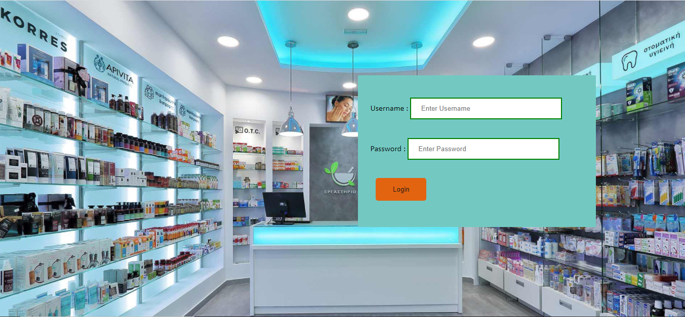

Home Page:



Medicine Page:

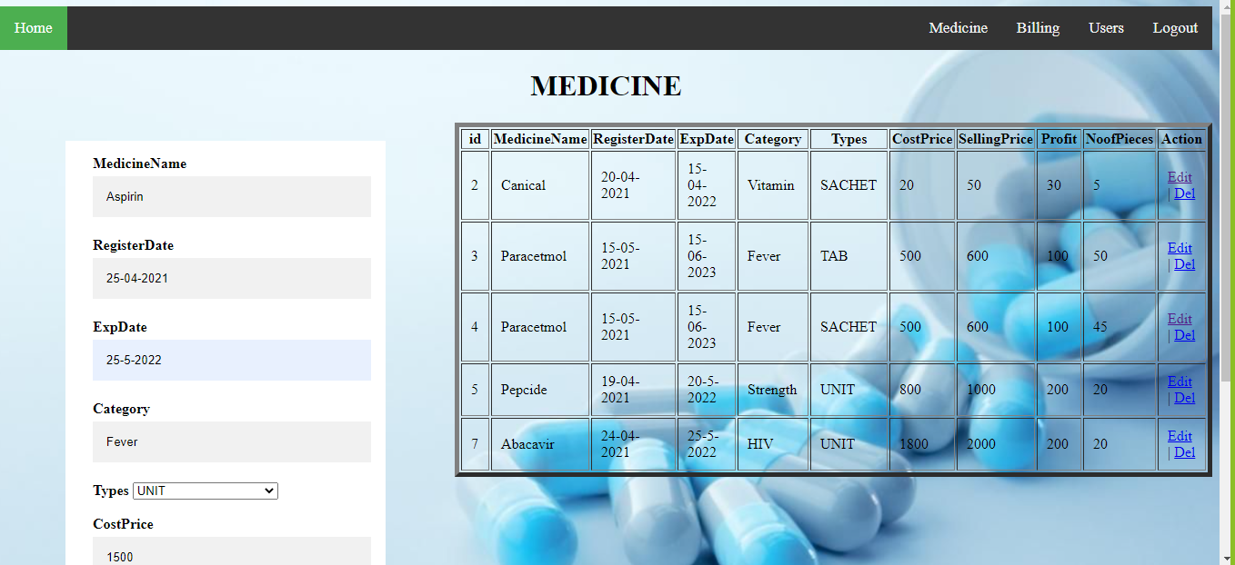

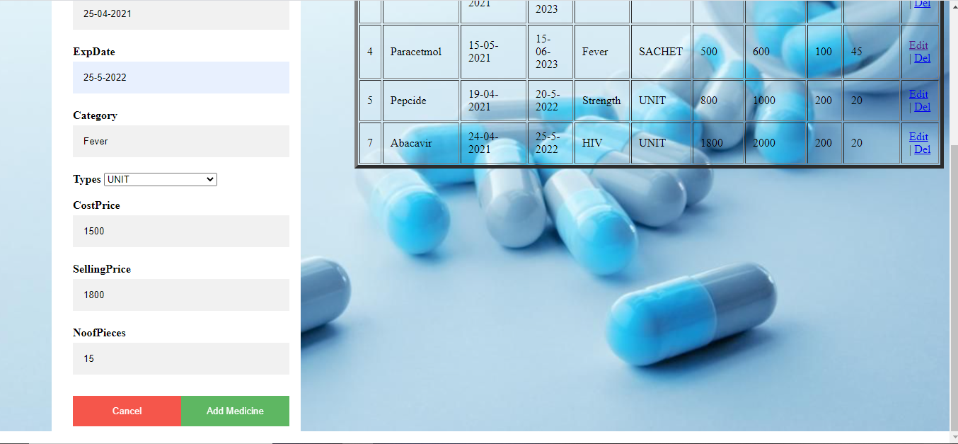

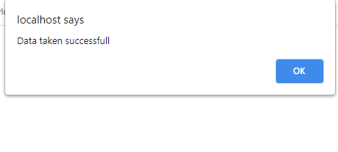

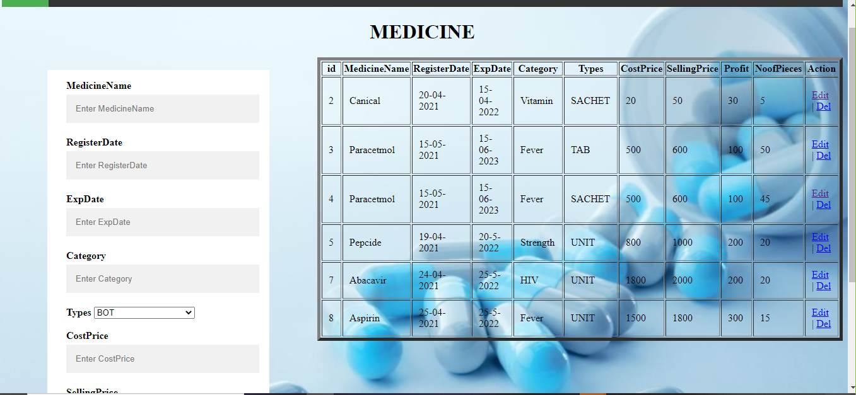

Medicine Page Data Structure:

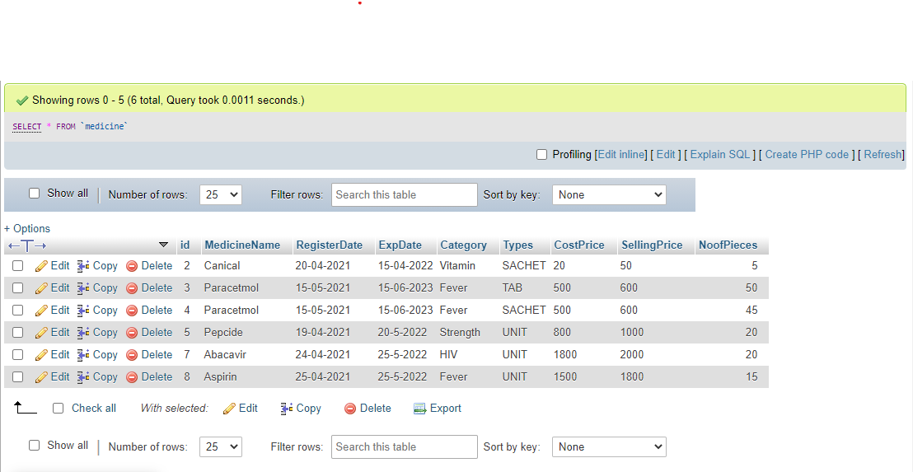

Buy and Billing Page:

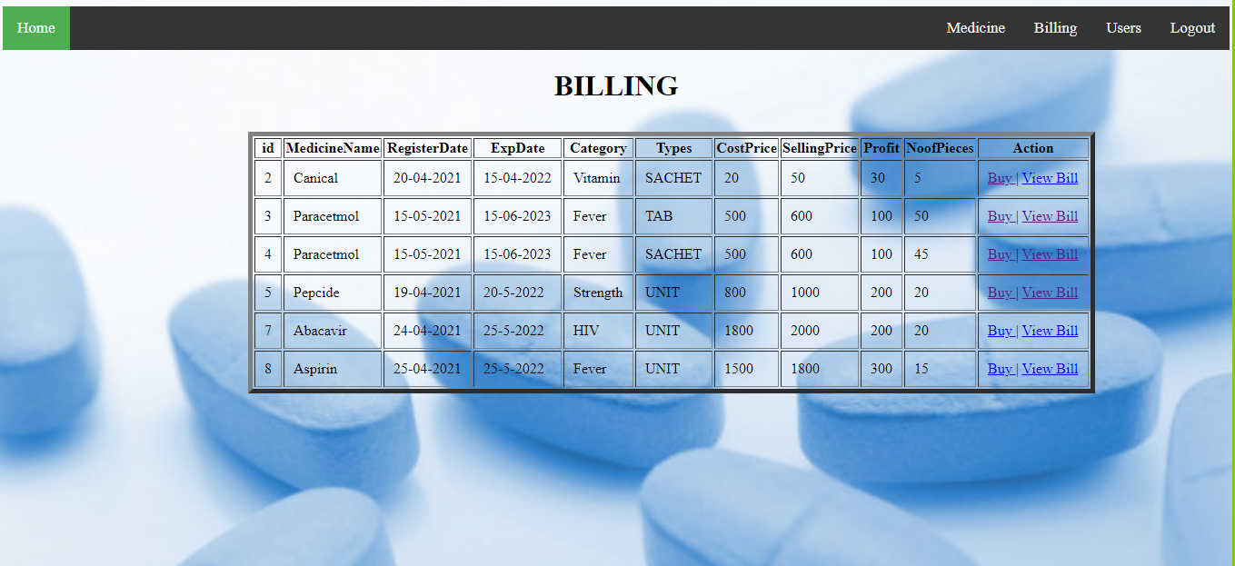

Now, if customer wants to buy the medicine, then the admin (he/she) should click the options in action. Then, it will redirect to the billing and sales report.

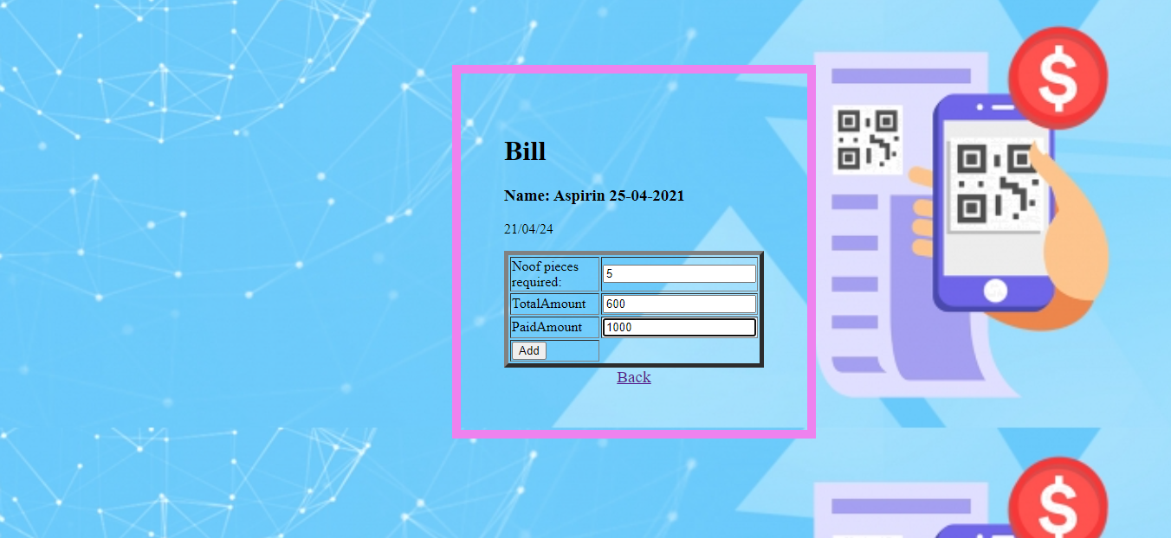

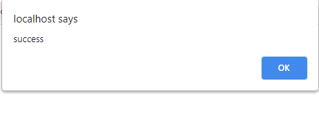

By clicking OK button. It will redirect to sales report page.

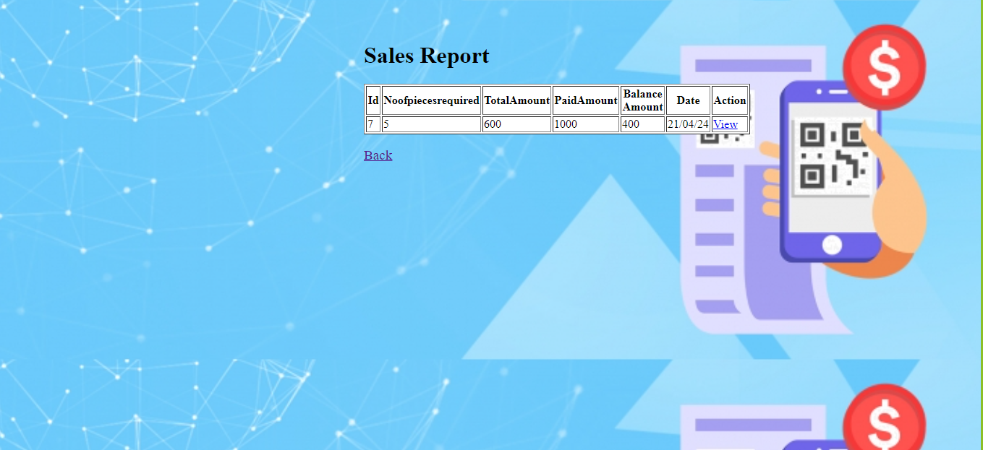

Now, the admin (he/she) should click the option in action to view the bill. Then, it will redirect to the billing form.

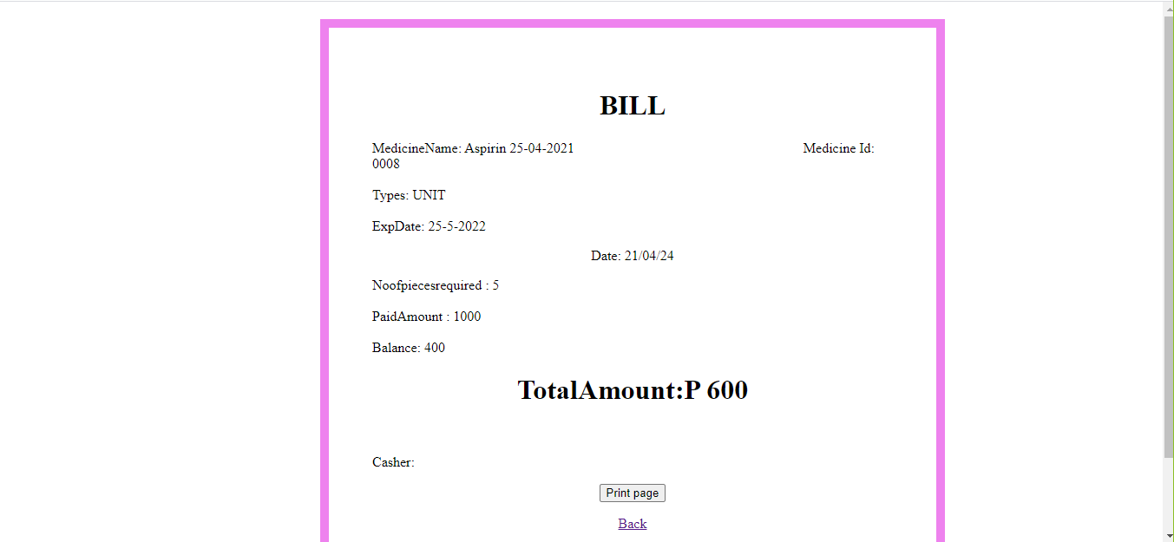

Now, the admin (he/she) should click the option print page so that the bill will come in the PDF form.

Bill Page Data Structure:

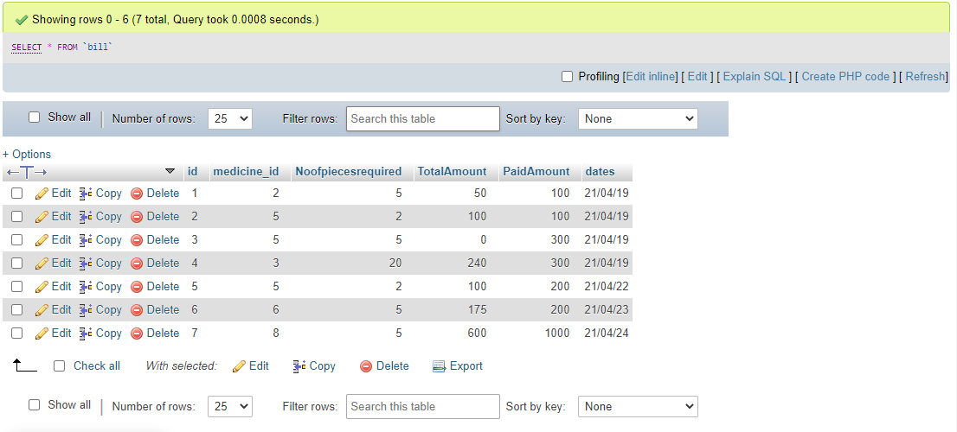

User Page:

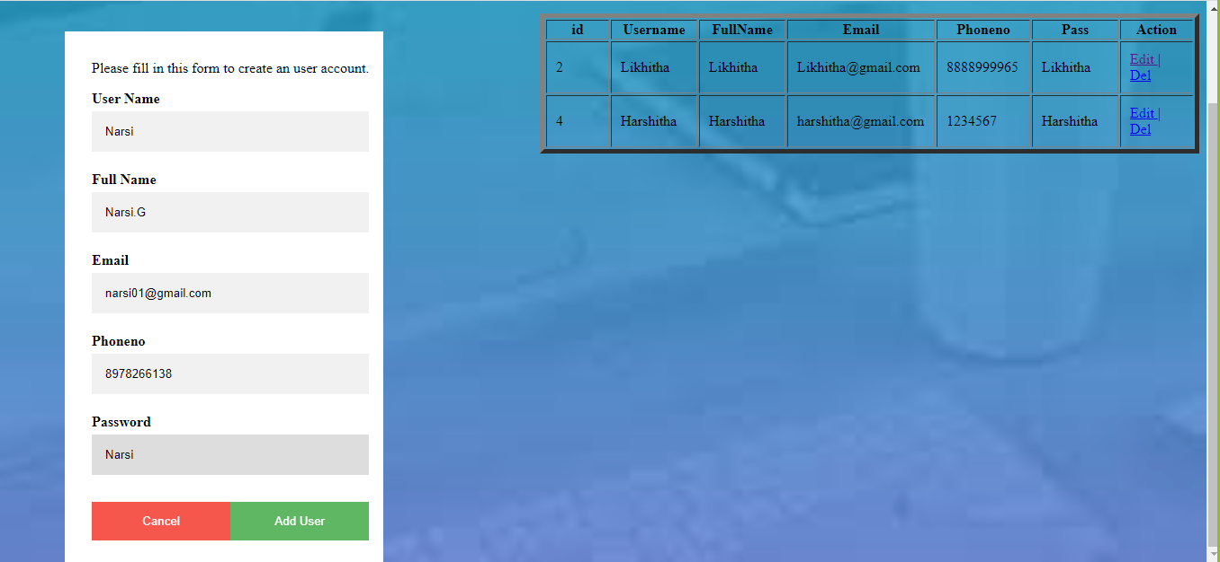

By clicking add user button.

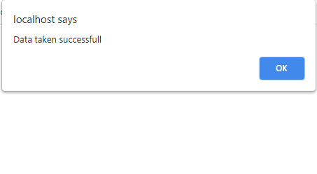

User Page:

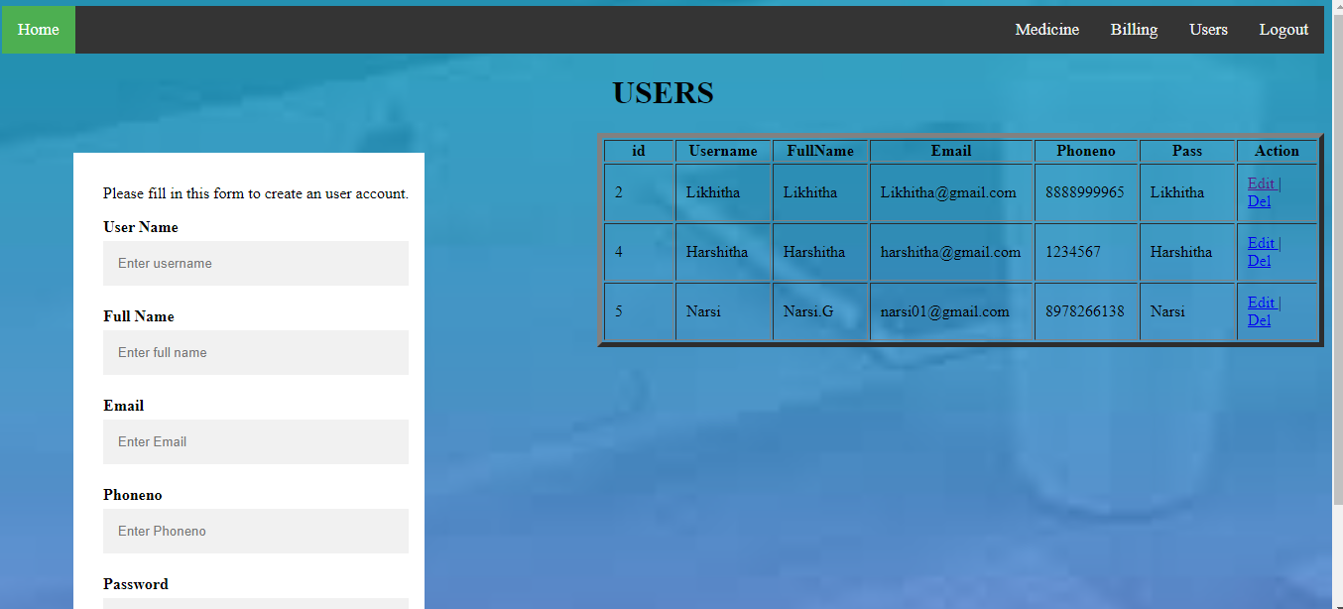

The new user is added and one can edit the password or delete the user in the action

Users Page Data Structure:

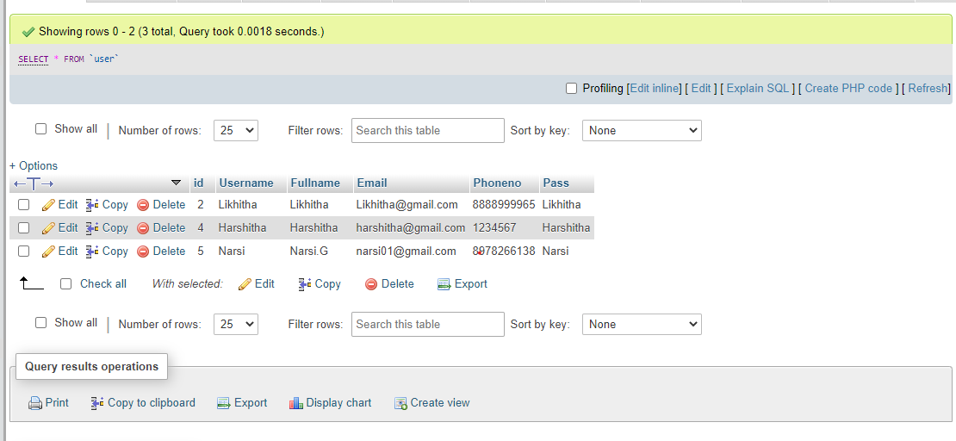

# End – User:

* Admin can add new Pharmacist and can view the pharmacists list.
* The User (Pharmacist) who wants to sell their medicine with a reasonable price.

**Conclusion**

This project has made us aware of the immense capabilities and the various uses of PHP, CSS, MYSQL and Apache server both individually and combined. We have raised one step further in terms of designing and developing a combined management system of both strock managing and Billing Automation which can be opted for any of the related stores.

It is a vital importance that the software must have the right type of modularity and openness so that it is manageable, maintainable and upgradable.

We conclude that the Pharmacy Management System is developed to satisfy the complete needs of medical store for their necessary usage and also to help them make things faster.

